

UNVEILING THE STRATA COLLECTION

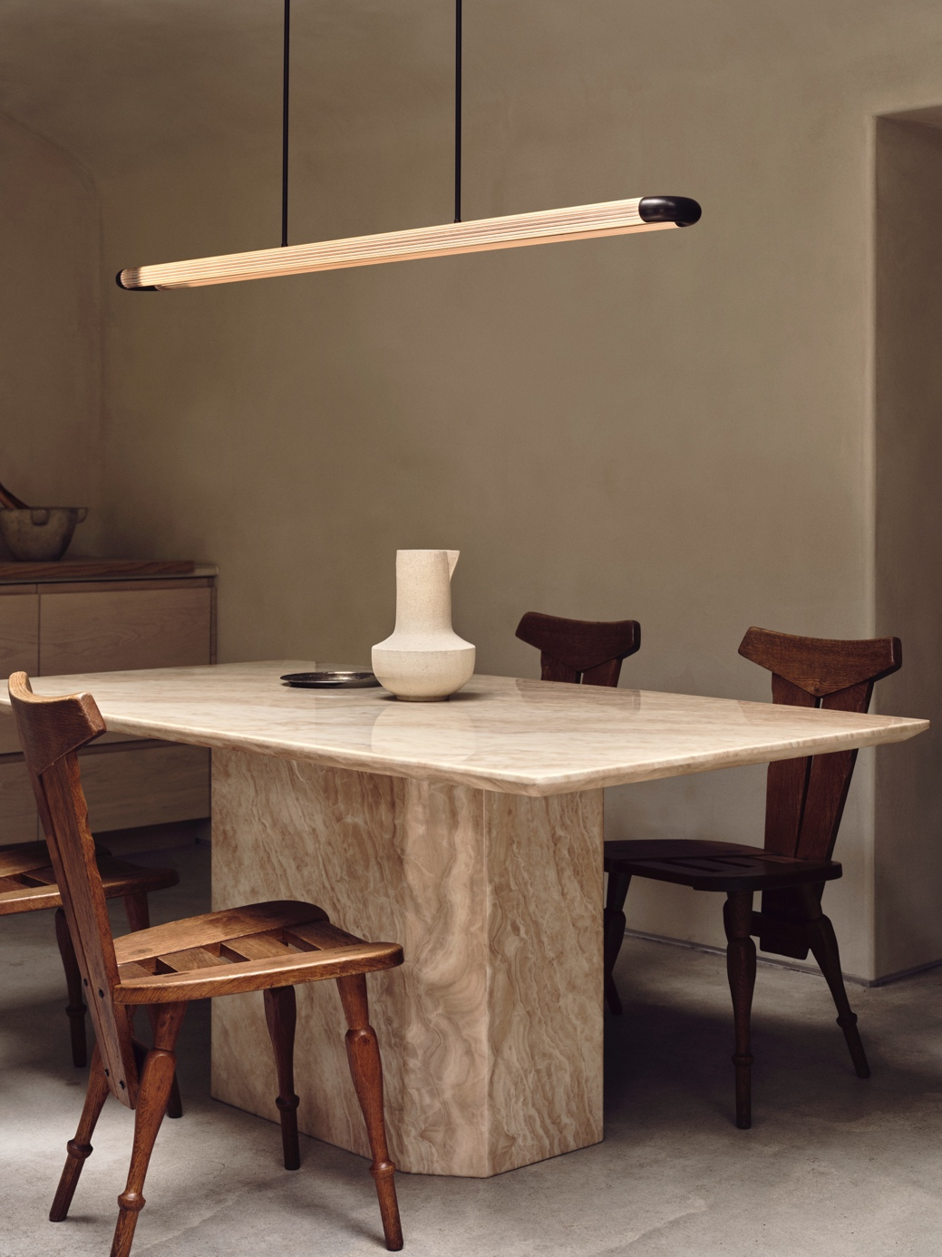

Experience the synergy of sophistication and artistry with the new Strata collection by J. Adams & Co.

The Strata collection is a celebration of craftsmanship and ingenuity by lighting brand J. Adams & Co. Designed to work in both residential and commercial projects, Strata showcases a range of versatile pendants and wall lights.

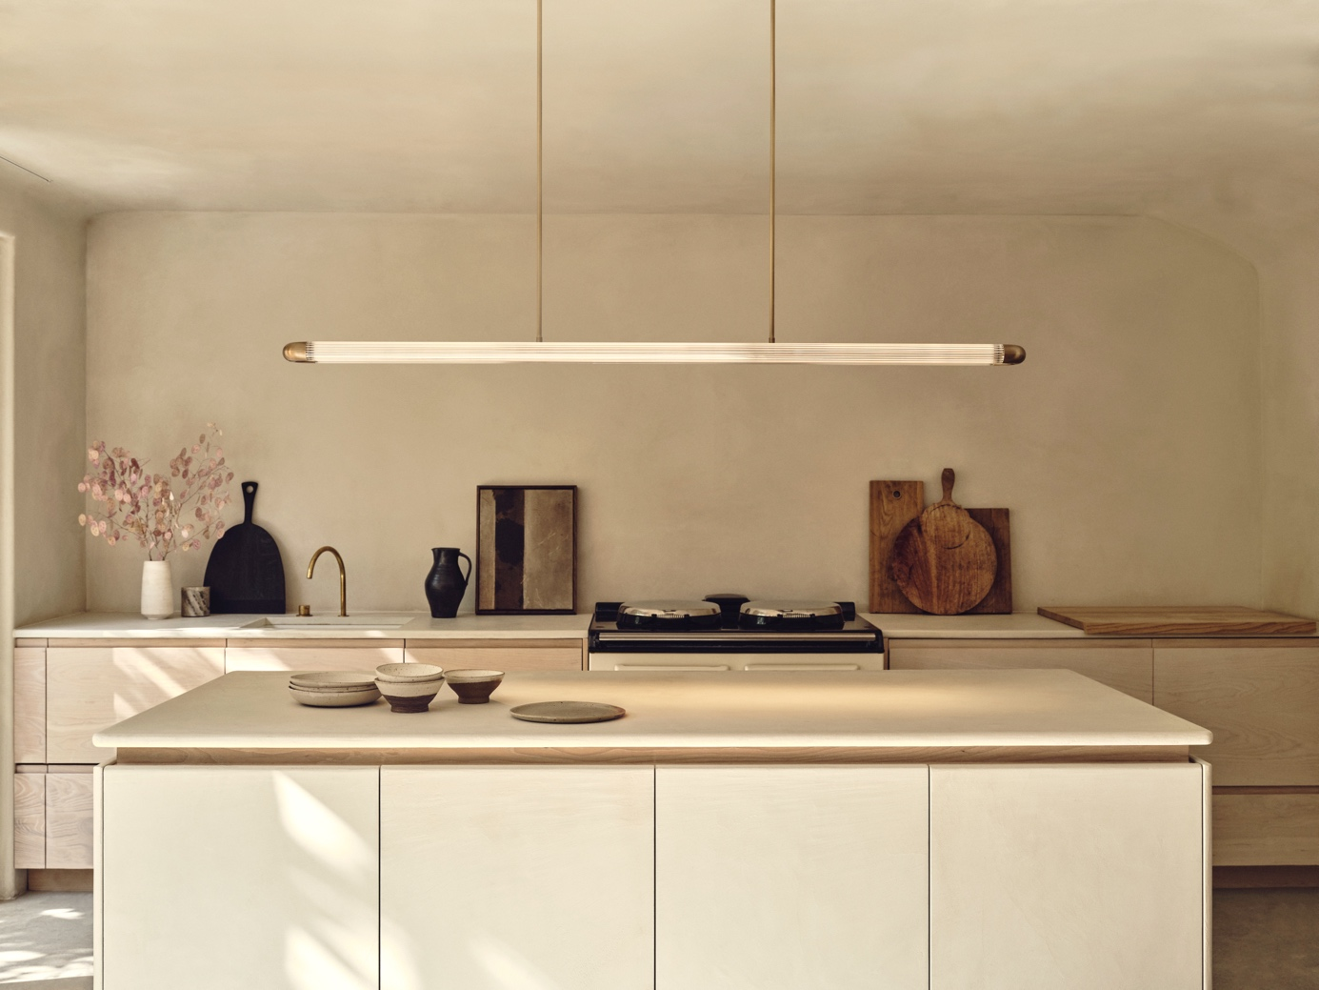

Playing with materiality and the beauty of light refraction through reeded glass, Strata provides an enchanting focal point. Each piece is expertly produced at the brand’s workshop using precision-cut glass and engineered solid brass.

At the centre of the Strata collection is the pendant; a linear design that pushes further boundaries of creativity and engineering. Two slim reeded glass tubes run parallel, linked by rounded brass endcaps to create the sense of a continuous loop. This structure is suspended from a brass core, featuring the brand’s signature Deco-inspired stepped detailing.

Spanning 1.5 metres, the elongated proportions of the Strata Pendant make it ideal for use over dining tables, kitchen islands and counter tops. The reeded glass diffuses the light, casting an even, low glare illumination onto the surface below and surrounding area. For longer tables and surfaces, Strata offers versatility and customisation; multiple pendants can be arranged in a row or joined together, as a bespoke option, to meet specific requirements.
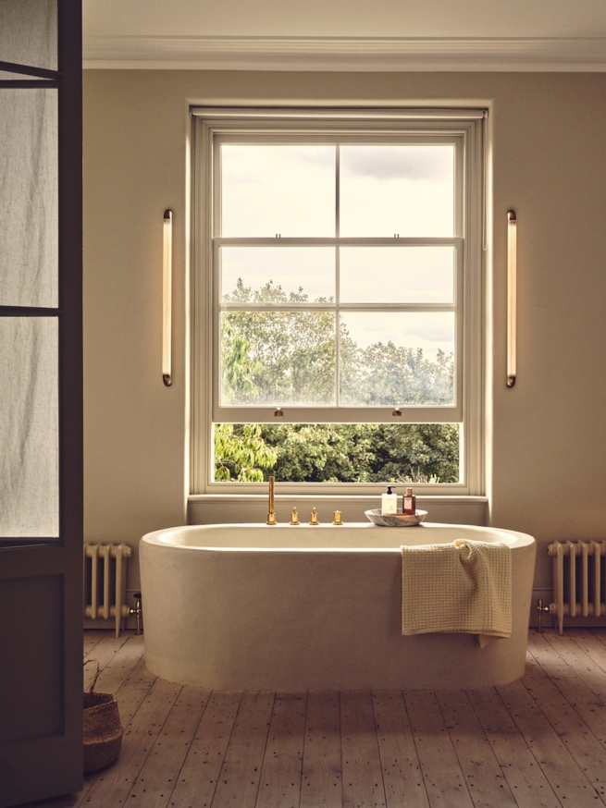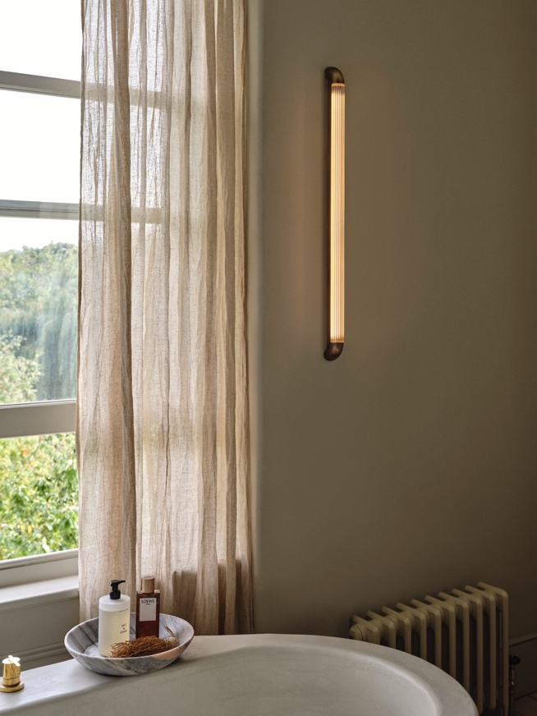

The wall light showcases the same captivating interplay of materials that characterises the collection. Emitting a delicate decorative light, the narrow tube of reeded glass is gracefully anchored by curved brass detailing. Available in two lengths (600mm and 900mm), the Strata Wall Light is perfect for bathrooms and bedrooms alike.

For high resolution imagery, videos, quotes and product loans, please contact press@jadamsandco.com

Notes to Editors:
J. Adams & Co is a British lighting manufacturer that specialises in elegant luminaires of unparalleled quality. Handmade in the UK, their Birmingham factory has over half a century of manufacturing and metalworking expertise. The brand seamlessly melds traditional techniques with a nuanced, modern sensibility, focusing on craftsmanship and longevity. The result: refined and contemporary lighting that is built to last.



